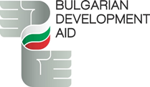

PUBLICITY AND VISIBILITY GUIDELINES
FOR
THE BULGARIAN DEVELOPMENT AID

TABLE OF CONTENTS
1. Introduction………………………………………………………………...…………………………………………………….………………………........3
2. Visual Identity of the Bulgarian Development Aid………………………………………………………………………………………….4

3. Practical requirements for the preparation of the Communication plan for publicity and visibility of the Bulgarian Development Aid………………………………………….……………………………….……………………………………………………………………………………………………..12

4. Guidelines for developing a Communication plan and completing item 5.2.1. of the Bulgarian Development Aid Application Form...………………………………………………………………………………………………………………………………………16

5. Report on the activities under item 5.2.1. of the Bulgarian Development Aid Application Form and on the implementation of the Communication plan……………………………………………………………………………………………………19

1. Introduction
The Bulgarian Development Aid aims to support the sustainable development of partner countries, while affirming Bulgaria as an active and consistent participant in international cooperation. A key factor in achieving these objectives is the promotion of the funded initiatives and their results by the beneficiaries in the respective partner country.
That is why the practical implementation of each project requires the preparation of a Communication plan and the provision of publicity. Communication plans for aid-funded initiatives in partner countries must be implemented with respect for the dignity of all stakeholders and in accordance with the principles of inter-cultural communication.
The Publicity and Visibility Guidelines for the Bulgarian Development Aid support the beneficiaries in the planning, preparation, implementation and reporting of their communication plans. They define the necessary tools and their practical application to ensure clear, reliable and effective message delivery. They contain a description of the visual identity of the Bulgarian Development Aid, as well as the main and recommended elements of the communication strategy.

2. Visual Identity of the Bulgarian Development Aid
Creating a visual identity is a key part of the publicity and visibility of the Bulgarian Development Aid. When implementing the Communication plan and using the logo and/or quoting support under the Bulgarian Development Aid, specific requirements apply with regard to: the visual layout of information and/or advertising materials and their distribution through the various communication channels. It is the responsibility of the beneficiaries to announce the support under the Bulgarian Development Aid in accordance with these requirements.
All information and/or promotional materials created by the beneficiaries must contain the following elements:
- The logo of the Bulgarian Development Aid;
- The flag of the partner country or the logo of the beneficiary implementing the project;
- Text in the official language of the partner country, preserving the meaning of the following text in English The project /Project Title/ is funded with the Bulgarian Development Aid (in case the name of the project is already mentioned in the relevant material, the text can be written as follows: This project is funded with the Bulgarian Development Aid.

Such information and/or promotional materials include:
- Printed information materials (brochures, leaflets, newsletters, diplomas and certificates from conducted trainings, attendance lists, etc.);
- Promotional and advertising materials (banners, posters and advertising panels, etc.);
- Small promotional and advertising materials (pens, USB, key-chains, badges, folders, notebooks, stickers, etc.);
- Information boards and signs (For all buildings, premises, entrances, fences and facilities that are built, repaired, renovated or equipped with the financial support of the Bulgarian Development Aid, it is mandatory to install an information sign. It is installed in a visible and easily accessible place to the public (e.g. next to the main entrance or on the external fence) and contains the official logo, together with the relevant text indicating the Bulgarian funding. The signs must be made of weather-resistant materials guaranteeing long-lasting visibility);
- Social media posts (banners, graphic images and other visual materials);
- Promotional and/or informational video materials and/or info-graphics and photographs to visually present the results of the activities implemented under the Bulgarian Development Aid.

When organizing and conducting events with the participation of stakeholders, the media and the general public, beneficiaries should necessarily announce the role of the Bulgarian Development Aid. Such events include:
- Public events: it should be explicitly announced that the respective project is financed with funds under the Bulgarian Development Aid, using the above elements of the information and publicity measures. Beneficiaries can do this by placing banners in the halls where the event is held, depicting the logo of the Bulgarian Development Aid;
- Media appearances (unpaid articles, publications, interviews, etc.): it is necessary to indicate the role of Bulgarian Development Aid. It is also advisable to mention the value of the grant;
- Paid publications and broadcasts (advertising boxes, advertising spots, title cards, reports, films, PR materials, etc.): the following text should be incorporated: The project (Project Title) is funded with the Bulgarian Development Aid and to put the logo of the Bulgarian Development Aid as a mandatory visualization element.

Placing the Logo on Acquired Equipment and Property

All materials, items, equipment and vehicles purchased or acquired with the financial support of the Bulgarian Development Aid under the specific project must be branded with the official logo. The marking should be placed in a visible place using wear- and weather-resistant materials (e.g. stickers, signs or direct printing). The size and proportions of the logo shall take into account the dimensions of the respective property, ensuring its clear visibility and legibility.

Use of the mandatory visual elements – logo of the Bulgarian Development Aid (1); flag of the partner country or logo of the beneficiary implementing the project (2); text in the official language of the partner country, preserving the meaning of the following text in English: The project (Project Title) is funded with the Bulgarian Development Aid (3):

(1) Logo:

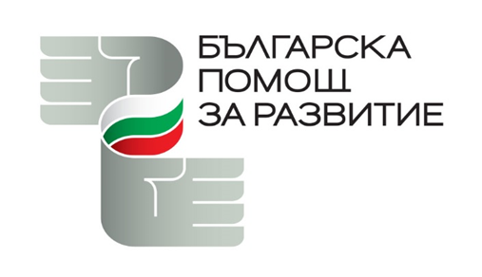

Colour Values of the logo:

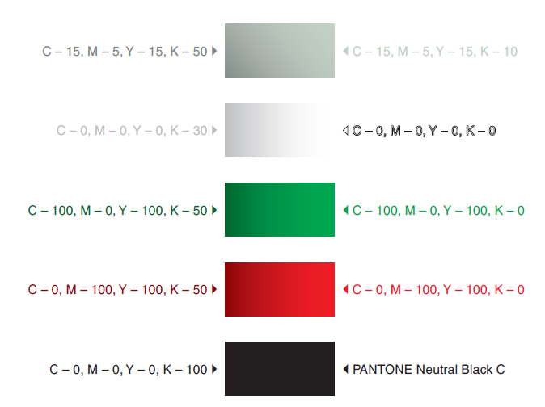

Proper use of the logo:
- The two main elements of the logo cannot be separated. The logo must be published in its entirety;
- Individual logo elements cannot be changed (colour, text, etc.). The logo cannot be translated into other languages (except the approved versions in Bulgarian and English);
- The logo cannot be replaced by other symbols related to Bulgaria (e.g. logo of another initiative, Bulgarian national flag, coat of arms, etc.).
Correct: The logo is used in its entirety. The logo has not been changed.
Incorrect: The integrity of the logo has been compromised. The proportions of the first logo have been altered, while text has been removed from the second logo.
Incorrect: The integrity of the logo has been compromised. The first logo is framed and shadowed. In the second, there is a change in colours. |  | 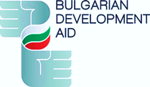

(2) The flag of the partner country or the logo of the beneficiary implementing the project:
- The use of the partner country's flag or the beneficiary's logo should be consistent with their requirements for the use of visual elements for visibility and publicity;
- In the case of a project that is co-financed and/or implemented simultaneously by another donor and/or international organization, the listed mandatory elements shall be consistent with and adapted to the publicity rules of the co-financing organization, and the mandatory elements listed above shall also be present.

(3) Official text:

Requirements for the use of the official text:
- It must be in the official language of the partner country, and may also be written in English when communicating with international partners;
- It must retain the meaning of the following text in English: The project (Project Title) is funded with the Bulgarian Development Aid;
- In case the name of the project is already mentioned in the relevant material, the text can be written as follows: This project is funded with the Bulgarian Development Aid;
- In the event that the information materials are intended for an audience speaking a different language than the official language of the partner country, the text may be written in English and, if necessary, in the language of the target audience, if it speaks the same language other than the official language of the partner country;
- When preparing analytical and research materials, policy documents, declarations, etc., a text should be placed after the title page, which should preserve the meaning of the following text in English: This (product: report, study, etc.) is created within the Project (name of the project), funded by the Bulgarian Development Aid. The content and the positions and opinions expressed are the sole responsibility of (name of the beneficiary) and in no way reflect the official position of the Bulgarian Development Aid and the Republic of Bulgaria.

Example use of the three mandatory elements in a graphic image that can be used as a physical poster, social media visualization, web page publication, banners, carousels, etc.

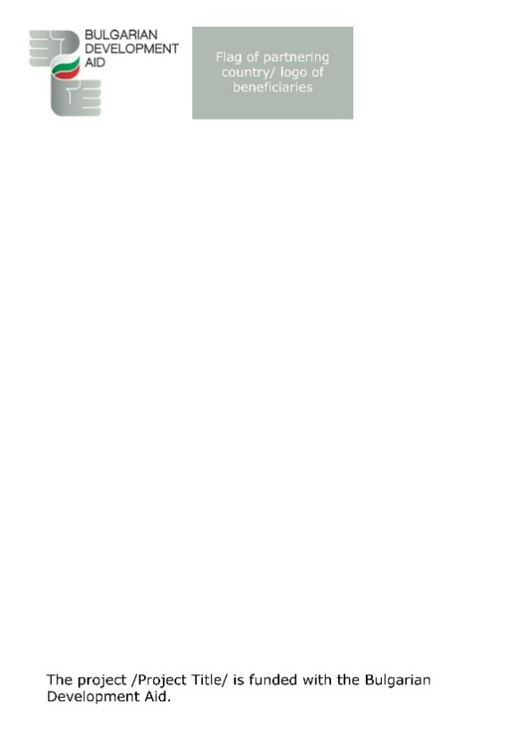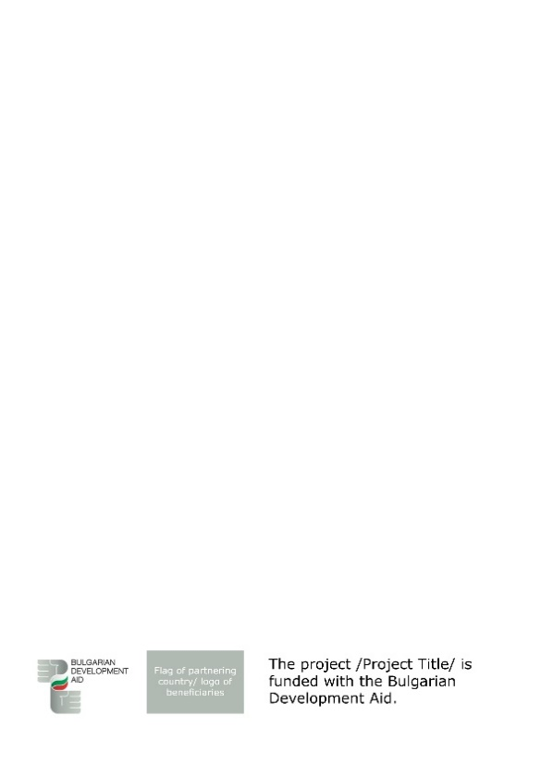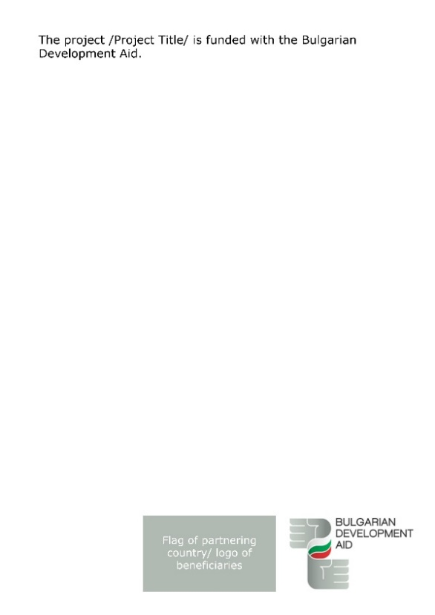

3. Practical requirements for the preparation of the Communication plan for publicity and visibility of the Bulgarian Development Aid

The preparation of the Communication plan should comply with the following minimum requirements and mandatory elements, which are consistent with the amount of funding received by the beneficiaries and with the indicators for publicity and visibility of the Bulgarian Development Aid set out in the Mid-term Programme of the Republic of Bulgaria for Development Assistance and Humanitarian Aid.

The table describes the specific requirements for number of events, level of media activity, number of brochures, signs, branded materials, etc.
Amount of financial aid →  Communication Activity Type ↓ | Up to EUR 25,000 | Between EUR 25,000 and EUR 40,000 | Over EUR 40,000
Organization of public events (meetings with stakeholders; public discussions and round tables; cooperation with civil society organizations for the positive presentation of the main goals and messages of the Bulgarian Development Aid) | Mandatory organization of 1 event with over 50 participants/attendees. | Mandatory organization of 2 events with over 50 participants/attendees. | Mandatory organization of 2 events with over 50 participants/attendees. Organizing additional events is highly recommended.
Media appearances (press conferences, unpaid articles, publications, reports, interviews, etc.) | All projects should publicly announce the start of the implementation of the activities financed with funds under the Bulgarian Development Aid. This can be achieved by disseminating press releases, holding public events or a press conference in order to familiarize stakeholders, the media and the general public with the objectives of the project.  During these activities, the support under the Bulgarian Development Aid must also be presented.  The beneficiaries should strive for information about the specific project to be disseminated by at least one national television and one national radio.
Paid publications and broadcasts (advertising boxes, advertising spots, title cards, reports, films, PR materials, etc.) | Paid media appearances are not a mandatory element of the Communication plan.  It is possible to create media partnerships.
Printed information materials (brochures, leaflets, newsletters, diplomas and certificates from conducted trainings, attendance lists, etc.) | The dissemination of printed materials during the events to participants and stakeholders is advisable.
Promotional and advertising materials (banners, posters and advertising panels, etc.) | Creating and using promotional and advertising materials during events that reach participants and stakeholders is obligatory.
Small promotional and advertising materials (pens, USB, key-chains, badges, folders, notebooks, stickers, etc.) | It is recommended that the beneficiary provides for the production and distribution of small promotional materials within the project implementation. | It is mandatory for the beneficiary to distribute small promotional materials within the project implementation.
Information boards and signs | It is recommended to place at least one information board/sign for the project, with information on the financial support under the Bulgarian Development Aid according to the nature of the project. For projects involving the construction, repair or equipment of buildings and premises, the beneficiary must affix an information sign with the logo of the Bulgarian Development Aid and the relevant accompanying text. The sign is installed in a prominent place (e.g. on the entrance, façade or fence) and provides clear visibility of the contribution of the Bulgarian side.  A text in the official language of the partner country should be used, preserving the meaning of the following text in English: "The Project (name of the project) is financed with funds under the Bulgarian Development Aid. Through development cooperation, Bulgaria contributes to a more balanced and equitable global development, taking its share of responsibility in efforts to eradicate poverty and achieve sustainable development."
Social media posts (banners, graphic images and other visual materials, etc.) | It is mandatory to create visualizations and publish information about the project and the activities implemented in 1 social network. | It is mandatory to create visualizations and publish information about the project and the activities implemented in 2 social networks. | It is mandatory to create visualizations and publish information about the project and the activities implemented in 2 social networks.
Promotional and/or informational video materials and/or info-graphics and photographs to visually present the results of the activities funded under the Bulgarian Development Aid | It is advisable to create video materials and/or info-graphics and photographs to be published on social networks. |  | It is mandatory to create video materials and/or info-graphics and photographs for publication in social networks.

4. Guidelines for developing a Communication plan and completing item 5.2.1. of the Bulgarian Development Aid Application Form

In the Bulgarian Development Aid Application Form, it is necessary for the beneficiary to provide a detailed description of the communication program of the planned initiative. This description should include the identification of the target groups, as well as how they, stakeholders and the general public will be informed about the implementation of the project and the results achieved. This part of the Application Form can describe specific communication channels, information materials and events, such as: social media accounts, website, advertising materials, media appearances, organized public events, etc. In the Application Form, the applicant beneficiary should present the main elements of the Communication plan, as well as the planned public events, with the relevant quantitative indicators set for the audience reached, which can be found in item 5 of the Guidelines.

First of all, the Application Form should identify and describe the target groups targeted by the Communication plan of the initiative. These can be the project participants, the local population and/or a wider audience who should be informed about the benefits of the implemented activities. Depending on the specificity of the target groups and the nature of the project, the beneficiary should consider how to formulate an appropriate message and how to use the mandatory communication channels referred to in item 3 of the Guidelines, describing it accordingly in the Application Form.

Secondly, it is necessary to present a communication strategy that reflects both the mandatory requirements and the recommended guidelines, in accordance with the planned funding of the initiative (See item 3). A detailed plan should be submitted, including:

(1) Organized events that will be part of the communication program:

Such events may include meetings with stakeholders, public discussions, round tables, as well as joint initiatives with civil society organizations to promote the main goals and messages of the Bulgarian Development Aid.

In addition to describing the events themselves, it is necessary to indicate how the Bulgarian Development Aid will be presented and promoted during them. This should be in line with the visual identity (item 2) and the communication requirements (item 3) towards the beneficiaries. Various communication tools can be used, including: printed information and advertising materials (in different formats and scales), social media posts and other appropriate channels.

Participations in international and local forums, webinars, conferences and events that promote the results of the project funded under the Bulgarian Development Aid may also be envisaged within the planned events, if this is within the scope of the plan prepared by the beneficiaries. This can be achieved through presentations, participation in panel discussions or the provision of documents, reports and research developed during the project implementation.

(2) Media appearances:

A plan for media appearances, prepared in accordance with the requirements set out in item 3, shall be presented. The plan should necessarily include a public announcement of the start of the implementation of the activities financed with funds under the Bulgarian Development Aid, as well as recommended paid and unpaid media appearances. The Beneficiary may propose a paid media partnership plan with a media of its choice or a strategy to promote unpaid publications by disseminating information materials to the media through press releases. Activities such as conducting media campaigns and interviews with representatives of Bulgarian institutions and beneficiaries of the aid could be included, contributing to wider publicity and engagement.

It should be described in which way the support of the Bulgarian Development Aid will be explicitly announced in media appearances. This can be realized by sharing promotional and informational videos and/or info-graphics and photographs visualizing the effect of the initiative and complying with the requirements for visual identity of the program (item 2).

(3) Use of social networks and website:

A communication strategy for the use of social networks in the implementation of the initiative should be presented. It may include a plan for regular publication of news, success stories and real examples from projects funded under the Bulgarian Development Aid. It is necessary to specify which social platforms will be used, what the format of the content will be, as well as the frequency of publication on the respective platforms. It should be specified how these channels will announce the Bulgarian Development Aid, in accordance with item 2.

(4) Additional use of the mandatory and recommended elements of the Communication plan:

The use of the other mandatory and recommended communication tools should also be described, including: printed information materials, promotional and advertising materials, small size promotional and advertising materials, information boards and signs and promotional and/or informational video materials and/or info-graphics and photographs that visually present the effect of the Bulgarian Development Aid. All communication channels used should be aimed at presenting concrete examples of results achieved. This can be done by presenting statistics, personal stories, interviews, and other appropriate forms of storytelling. These examples can cover a wide range of achievements – from restoring infrastructure and improving the social environment and/or social services to sustainable management of natural resources.

The Communication plan must be fully consistent with the visual identity of the Bulgarian Development Aid and the mandatory elements in relation to the amount of funding requested.

5. Report on the activities under item 5.2.1. of the Bulgarian Development Aid Application Form and on the implementation of the Communication plan

The report on the communication activities should provide a detailed description of the work carried out within the framework of the implementation of a project financed under the Bulgarian Development Aid. The main focus should be on the communication activities carried out under the project, their implementation and the results achieved.

The report should cover all communication (e.g. social media campaigns, videos, printed newsletters) and organisational activities (e.g. conferences, round tables, etc.). For each of the activities it is necessary to provide the following information:
- name and type of activity;
- objective and result achieved;
- covered (target) group.

For each communication activity provided for in item 5.2.1 of the Application Form, the following should be indicated:
- the objectives set;
- the target audience;
- the defined key performance indicators (KPIs).

It is also necessary to evaluate the results achieved, for example taking into account:
- Social media communication: inclusion of quantitative analysis prepared through the analytical tools of the platform used, with key activity indicators such as: number of page visits, likes, followers, shares, and other relevant metrics.
- Printed and informational materials: indication of the number of materials created, as well as information on their distribution – period of distribution, number of copies distributed, place and manner of distribution.
- Unpaid media appearances: adding an active online link (hyper-link) to the relevant post and a brief description of its purpose (e.g. report, interview or news material). Where possible, include information about the results achieved - audience covered, media indicators such as number of likes, comments, shares, etc. This part of the report must include information about a press conference – date and place of the event, number of attendees, media coverage and other relevant information.
- Paid media appearances: provision of an online link (hyper-link) to the publication is required, as well as a more detailed description of the objectives of the report. Data on its scope, provided by the respective media - number of people reached, degree of engagement (likes, comments, shares and other media indicators) should also be included.

Regarding all public activities related to the visibility of the Bulgarian Development Aid, described in item 5.2.1 of the Application Form, it is necessary to take into account their implementation. The report should contain the following information:
- name and type of event;
- objectives of the event;
- target audience;
- main activities implemented during the event (for example: round table, public discussion, training, etc.);
- results achieved, accompanied by photo material and attendance list (where possible).

The report should be supplemented with quantitative data, as well as with photographic and video material, where applicable.

*Important! When accounting for the costs of implementing the Communication plan, the implementation of the set indicators will be taken into account. In case a separate activity from the Plan is not implemented and/or the indicators are not reached, it is possible that the costs may be partially or completely not recognized.

